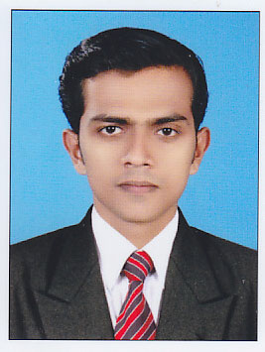

LIJO KOONAN

Cell:+919895731348
+919619492723
Mail: kplijo@gmail.com

Post Applied For : Roustabout

Personal Profile

Permanent Address : Koonan House Pullurp.o
Thuravankunnu,Irinjalakuda,
Thrissur Dist.,Kerala-680683
India.
Nationality : Indian
Age / Date of Birth : 31years, 29/05/1986
Sex / Marital status : Male / single
Religion / Caste : Christian / R.C
Languages known : English, Hindi, Malayalam

Educational Profile

- Diploma In Marine Mechanical (Indian Technical Education Society)
- Plus Two – Commerce (Board of higher secondary, Kerala)
- S.S.L.C (General Education Department, Kerala)
Experience

- 4 Year experience as Roustabout in jackup Rig ABAN III,ABAN OFFSHOR LIMITEDMumbai,India(07.01.2012 to 15.05.2016)

Documents | No. | Date Of Issue | Date Of Expiry | Place Of Issue
Passport | N4065281 | 02/11/2015 | 01/11/2025 | Cochin
Yello Fever Vaccine | L.5240 | 21/07/2016 | 20/07/2026 | Mumbai

Courses | Certificate no. | Date Of Issue | Place Of Issue
P.S.S.R | PSSR/09-2017/1289 | 08/03/2017 | Kochi
E.F.A | EFA/11-2017/831 | 11/03/2017 | Kochi
F.P.F.F | R FPFF/EMA/78-17/001446 | 17/03/2017 | Kochi
P.S.T | R PST/EMA/77-17/001420 | 17/03/2017 | Kochi
H.U.E.T | UMA/HELI/029/2012 | 08/12/2012 | Mumbai
S.T.S.D.S.D | STSDSD/05-2017/272 | 16/03/2017 | Kochi

Objective

To seek a challenging career in an esteemed Organization with a competitive and challenging environment and utilize my creativity, hardworking and education to its full potential.

Personal plus

- Hard Working to meet tough deadlines.
- Comprehensive problem solving ability

I hereby declare that all the information put in resume are true to my Knowledge and i am ready to accept challenges of the future changes in the field and can work with on any platform.

Place : Mumbai

Date :…………..

LIJO KOONAN

